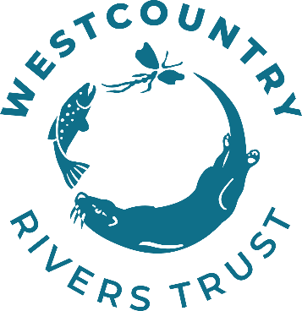
Westcountry Rivers Trust

Slowing the flow in the Budleigh Brook Catchment

CROC - Climate Resilient Otter Catchment

Invitation to Tender for the Provision of:

Bicton Mire Slowing the Flow

Bicton Common, Pebblebed Heaths
Feb-March2026

To be supplied to Westcountry Rivers Trust
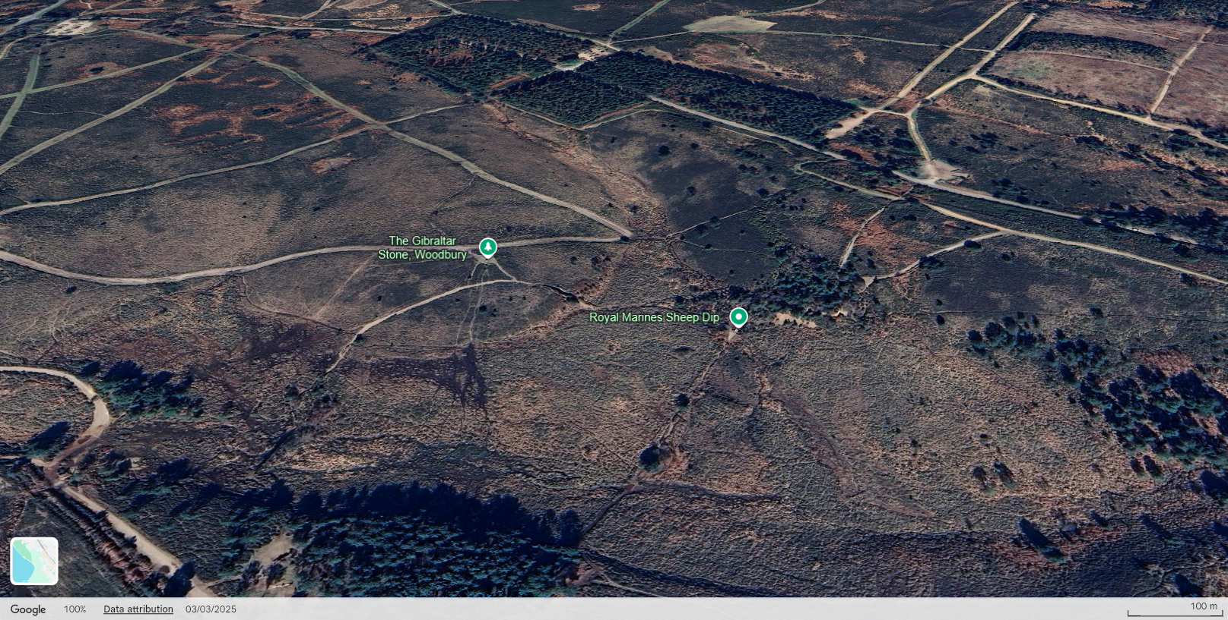
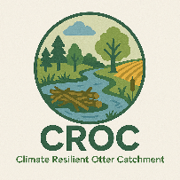
Date of Document: 8th January 2026
Prepared by: Milly Bowden
Authorised by:

Contents
1. Project Officer
2. Introduction & Overview
3. Scope of the Service 1
A) Site Location 1
B) Site Information 2
C) Services Required 3
D) Timescale 3
E) Special site considerations 4
4. ITT Responses 4
A) Respondent Guidelines 4
B) Tender Assessments: Evaluation and Process 5
C) Confidentiality 5
D) Finance 5
E) ITT Acceptance 5
5. Photographs for Reference 7
Appendix A: Concept Plan 10

Project Officer
For all enquiries and submissions concerning this Invitation to Tender, please contact:

Milly Bowden
Senior Farm Advisor
Westcountry Rivers Trust, Rain-Charm House, Kyl Cober Parc, Stoke Climsland, Callington, Cornwall, PL17 8PH

E: millybowden@wrt.org.uk M: 07930 371207

All enquiries for further information will be answered to all parties.

Introduction & Overview

Client: Westcountry Rivers Trust
Principal Designer: Westcountry Rivers Trust
Principal Contractor: TBC

- Company Background
Westcountry Rivers Trust (WRT) is an environmental charity (Charity №. 1135007, Company №. 06545646) established in 1994 to secure the preservation, protection, development and improvement of the rivers, streams, watercourses, and water impoundments in the West Country, and to advance the education of the public in the management of water and associated habitats.
- Project Background
The 237km² River Otter catchment rises in the Blackdown Hills and meets the sea at Budleigh Salterton. 103 residential properties flooded in the catchment in May 2023 due to intense rainfall creating significant runoff from agricultural land and protected sites, further runoff has been noted during Storm Ciaran.
The Section 19 Report following the May 2023 flooding makes specific recommendations around the need to deliver NFM upstream of impacted communities, and to better understand and improve land management practices. The ‘Climate Resilient Otter Catchment’ CROC project focuses advice and funding on both land management and NFM.
The Bicton Mire project was originally designed by Devon Wildlife Trust and Westcountry Rivers Trust, with consent from DWT, have adopted it for delivery.

Scope of the Service

Site Location

For- Bicton Mire - Clinton Devon Estates on behalf of the EA CROC project
As shown below, the site is located to the west of Yettington.
Grid reference SY 03975 85933.
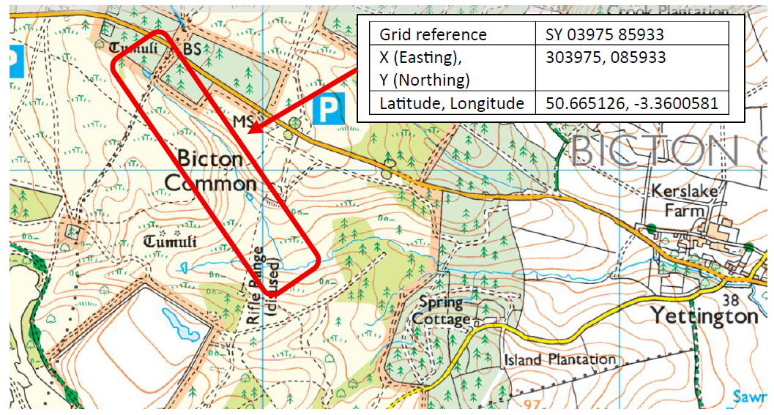

Google maps public car park locations for Pebblebed Heaths access with yellow lines as access tracks:
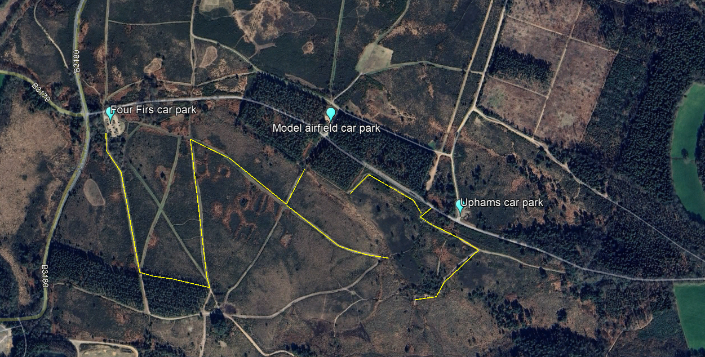

You are welcome to visit the site by arrangement. Please let the Project Officer know if you intend to visit the site to prepare your tender response. A member of WRT staff will organise permission and may accompany you to the site.

Site Information
- Bicton Common is located in East Devon within the East Devon Pebblebed Heaths, owned by Clinton Devon Estates. The common is approximately 123ha and encompasses SSSI & priority habitat for lowland fen.
- The site has public access and controlled grazing, in addition to use under a historic agreement by the Royal Marines as a training ground for recruits.
- The Royal Marines use an encampment within the common and an endurance course where groups of recruits run around the route across the common. This has caused damage and degradation to the fen, bog, and heath habitats, in addition to exacerbated erosion of peatland soils.
- There are no known water supplies (underground) and electricity (overhead) but site checks should be undertaken at each location.

Services Required
A series of 23 wool/woody logs and shallow peat bunds are to be constructed along the northern tributary. Installing leaky dams will hold back the highest flows so will slow the flow of water and the displacement of sediment and bed material.
Creation of 4 shallow scrapes will capture overland flows and ephemeral streams to hold back water giving it time to infiltrate into the surrounding landscape.

- An option of Ground Investigations according to the Consultant’s assessment and agreement with the Client as to whether they are needed.
- Appropriate risk assessments will be required for all elements of the services. Under CDM 2015 this includes a Designers Risk Assessment (DRA).
- Optioneering for the above outcomes is welcomed against your experience. WRT have provided a Concept Plan (Appendix A), based on technical input, however, WRT are not technical design experts, and while operating as Principal Designer under CDM regulations WRT expect the appointed designer to provide comment on feasibility, health and safety, and budget practicality of options based on your technical experience.
- The consultant must ensure that all elements conform to all relevant British and European Standards.
- A draft NEC4 Contract representative of the final version has been supplied. A final version will be provided at appointment, with opportunity to review before acceptance.

Timescale
The tender process is anticipated to follow the timeline presented in the table below:
Date |  |  |  | Action
 |  | 16th January 2026 | Invitation To Tender released.
 |  | 26th January 2026 | All queries to be submitted.
 |  | 30th January 2026 | All queries to be addressed and returned to all applicants.
 |  | 4th February 2026 | ITT Deadline for design quotes.
 |  | 6th February 2026 | Notification of intent to award tender
 |  | 13th Feb 2026 | Signed NEC4 contract awarded & delivered.
 |  | 13th March 2026 | Completion of NFM Works although could be later if Pebblebed Heaths Conservation Trust confirm revised date

Special site considerations
SSSI consent for these works has been sought but yet to be granted by Natural England – 9th Jan 2026.
Land Drainage Consent has been sought but yet to be granted by Devon County Council – 9th Jan 2026.
Please note that all works are subject to the approval of the above consents.
Due to the protected status of the Pebblebed Heaths SSSI and National Landscape and certain habitats, no additional work, other than discussed here, should be undertaken without prior permission.
In rivers that are sensitive to fish spawning no in-stream work is permitted to be carried out between the dates of 1st October to 31st May (dates inclusive). The site has been assessed to have no spawning habitat due to downstream barriers, therefore work can happen during the winter months but care must be taken to avoid disturbance of silt and releasing silt into the watercourse.
Trees and ground areas with active birds’ nests in MUST be avoided. Note birds may nest earlier or later than the official nesting season due to local conditions. An ecologist who works with the Pebblebed Heath Conservation Trust will be sought if needed to do an assessment of trees before any cutting. This work must be completed before the end of 2nd week of March (unless discussions with Pebblebed Heaths take place and dependent on SSSI consent).

ITT Responses

Respondent Guidelines
You are required to submit a written proposal, either hard copy or electronically to the Project Officer by the deadline.
- All proposals should include the following:

- Details of company experience in Natural Flood Management delivery
- Costings: including breakdown of delivery items to allow for partial project invoices, against specified item costs, if required
- An estimation of timescale and outline programme
- Details of staff to be delivering the work including relevant experience (e.g. CV)
- Completed draft NEC4 Contract supplied
- Current insurance certificates for Employer Liability, Professional Indemnity and Public Liability.
- Health & Safety information

- The draft NEC4 template provided requires you to fill out: The Consultant’s insurance details, the Consultant’s Contract Data, the Consultant’s Offer, the Price List, and to sign the contract as a formal offer.
- A detailed breakdown in the Price List of the NEC4 Contract allows for partial project invoices, against the specified item costs, if required.
- You are expected to supply all required information, or clearly state the reason for being unable to do so. Any return supplied must make it clear if any part of the Contractor’s offer does not comply with the Contract Data or the Works Information provided.
- In submitting a quotation, you are stating you are suitably qualified and experienced in work of this nature. If your tender is successful and the contract awarded, you are required to provide:

- Risk Assessments for any site visits planned and work undertaken.
- Details of proposed sub-contractors and current insurances (if applicable)

- Any assumptions used in preparing responses should be clearly stated. Any appropriate supporting documents e.g. programmes, plans, company brochures, organisation charts should be included with the tender submission.

Tender Assessments: Evaluation and Process
- A set of evaluation criteria has been prepared by WRT for the evaluation of every submission. Within each stage an initial evaluation will consider whether or not every requirement contained within the ITT has been fulfilled. The evaluation criteria will be based on price (40%) and quality (60%) with quality being assessed on ability to meet the requirements (25%), delivery/timescales (25%) and staffing arrangement (10%).
- All operations must strictly comply with all relevant Health and Safety, legal requirements and British & European codes of Best Practice.
- If you have any queries, please do not hesitate to contact WRT.

Confidentiality
- All information supplied by WRT in this tender to date, and any further information supplied during the tender process, is confidential and must not be shared with any other organisations unless WRT agree permission in writing. The confidentiality extends to all recipients of this information.
- This competitive invitation to tender process has been performed anonymously. Prospective contractor / invitee details will not be shared with other contractors by WRT. Any sensitive information shared with WRT as part of your response shall remain so between WRT and the prospective contractor. All enquiries for further information will be summarised anonymously and answered to all parties.

Finance
- This project is financed under the Climate Resilient Otter Catchment - CROC.
- Funding for this contract is sponsored by the Environment Agency.
- Invoicing terms are detailed in the NEC4 contract.
- When invoicing, the invoice must clearly state the awarded NEC4 contract.

ITT Acceptance
- To simplify exchange of information regarding this Invitation to Tender (ITT) please nominate one point of contact with relevant telephone number/s and email address.
- Please direct any questions regarding this ITT content or process to the Westcountry Rivers Trust Project Officer. All questions should be submitted to the Project Officer named above.
- Please make sure any questions are submitted in good time for answers to be collated and distributed. A deadline may be in place for any queries to facilitate the fair tendering process for all respondents but should be no later than 1 week prior to submission deadline.
- Where there is a valid reason, WRT reserve the right not to accept your submission, or any other quotations received. WRT are not liable for any cost you may incur in the preparation of your quotation.
- If you have any queries, please do not hesitate to contact WRT and we look forward to receiving your response.

Photographs for Reference

 | 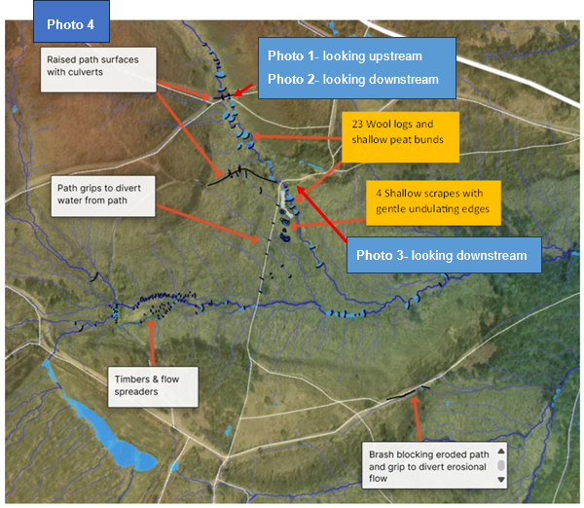
1 | 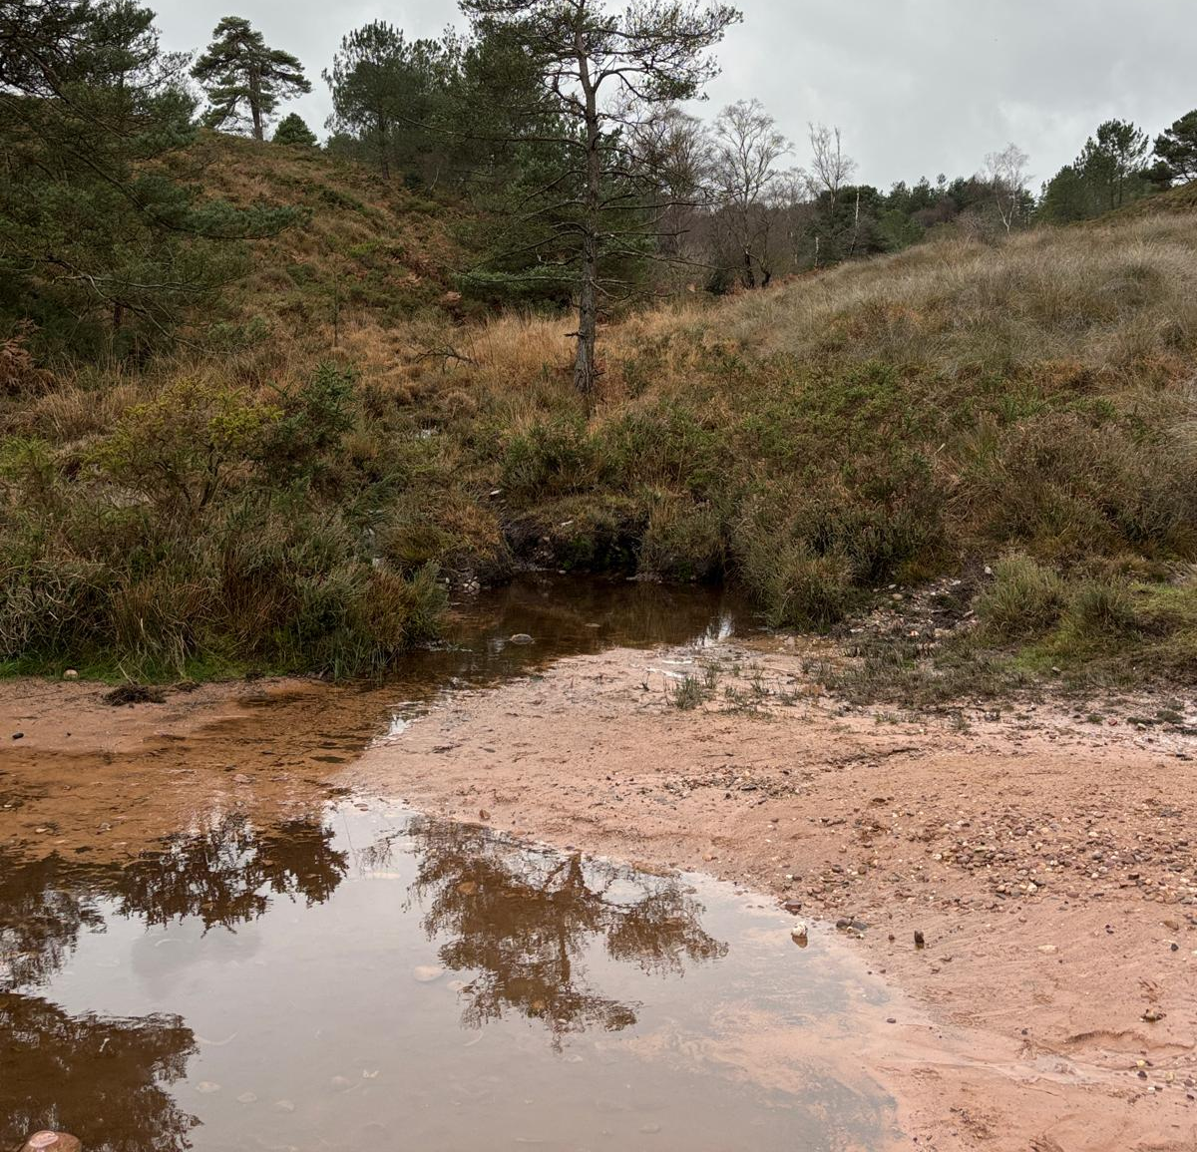
2 | 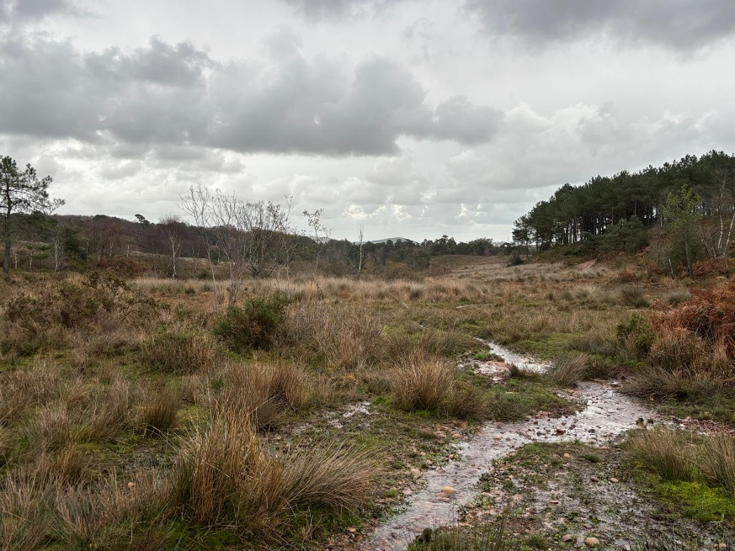
3 | 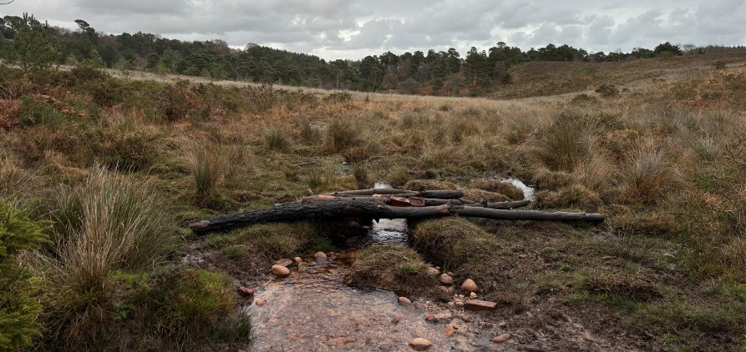
4 | 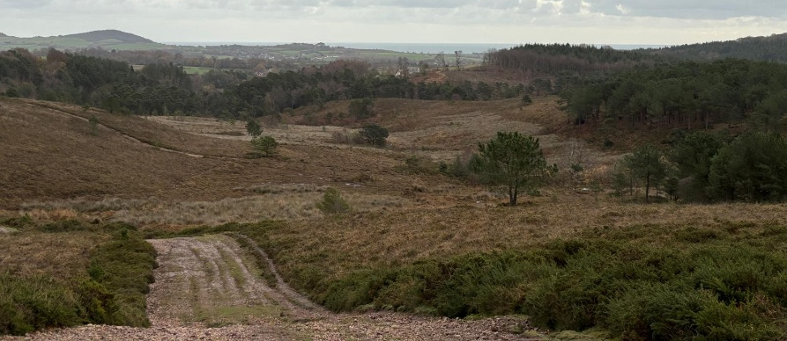
 | 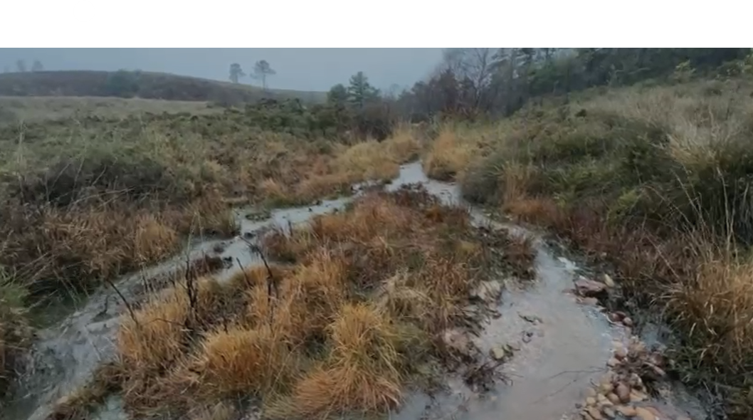

Concept Plan
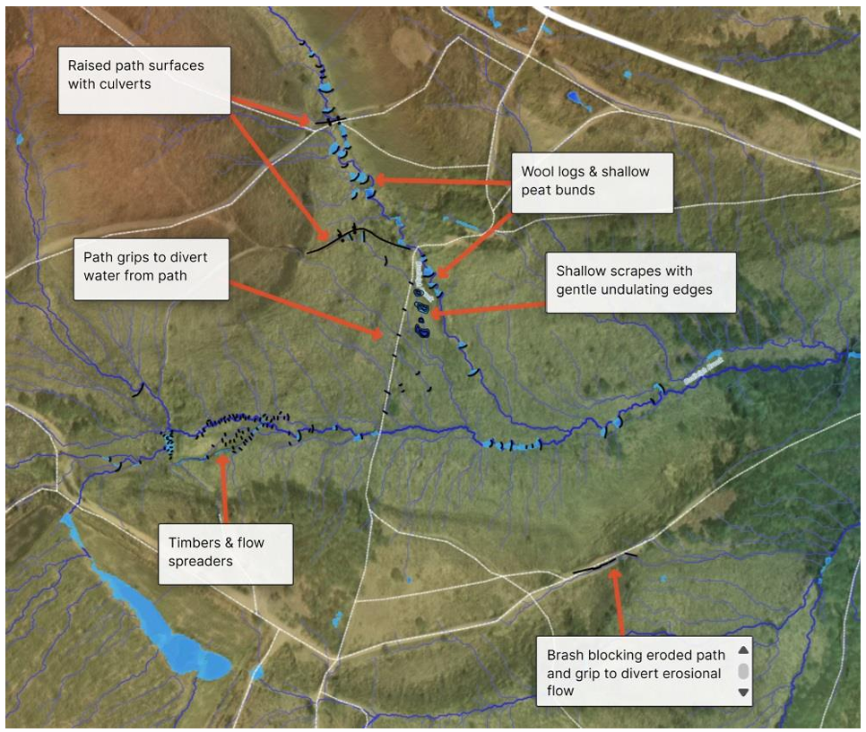
23 Wool logs and shallow peat bunds
4 Shallow scrapes with gentle undulating edges
Items in the orange text boxes are to be completed in this phase.

Wool/woody logs
Fleece from sheep can be used in different ways to slow water flows, capture sediment, and disrupt erosional energy. The wool can be made into logs or stuffed into dams which are then secured in place to provide a permeable barrier that will raise water levels using natural materials. The fleeces will provide a more sustainable alternative to coir rolls or matting and can be processed in the UK without synthetic materials or importing coir.
Within the valley basin, flow spreader logs on woody dams can be used.
The size, design and construction techniques for leaky dams are site specific. Works will be carried out by a trusted contractor. General design principles for woody log dams are as follows (this will be adapted for wool logs):
- Carefully selected trees along the watercourse will be felled to provide the materials for constructing the leaky dams. This material will likely need to be selected from adjacent Clinton Devon plantation woodlands.
- The leaky dam should be 2 times the width of the channel.
- Construct the dam from logs large enough to span the water channel and out on to the floodplain to provide a stable and long-lasting structure.
- Align dams at right angles to channel banks to reduce bank scour.
- Build dams to allow low flows and fish to always pass unimpeded at all times.
- Site dams on slow flowing reaches of the watercourse.
- Build dams to a height sufficient to encourage water to spread onto the floodplain upstream of the dam or hold water within the channel itself. Note it is not advised to build the dam higher than approximately 0.5 m.
- Steel pins can be used to secure the structure to the ground and create to a large mass of logs which is unlikely to move during high flows.
- Build dams in series (minimum 3 dams) at a spacing between dams of about 5-7 times the width of the channel.
- Make sure dams are not installed directly upstream of pinch points such as bridges or culverts that back up flows and are likely to swamp the dam. Dams should be no closer than 20m from culverts in offline ditches and at least 30m away in the river channel.
‘Cross design’ woody debris dams.
Diagram of flow spreader design built upon a cross style woody debris dam.

Peat bunds
The size, design and construction techniques for peat bunds are site specific. Works will be carried out by a trusted contractor. General design principles are:
- Carefully remove the surface vegetation (turves) in strips and set them aside to be used for capping
- Excavate degraded peat
- Use the good, wet peat excavated to construct a bund
- Thoroughly compact this peat layer, building it up to create a solid, watertight barrier up to 300mm height
- Place the reserved surface vegetation (turves) back on top of the compacted peat, butting them together to prevent erosion.
- Compact the turves firmly onto the bund.
- Backfill any borrow pits with degraded peat, reprofile the area to a gentle slope, and replace the turf or vegetation to minimise bare peat.

Scrapes
The next step beyond wool logs, dams & flow spreaders would be to create habitat on the adjoining land to the bank which will hold water when the water is overtopped from the channel by these interventions. This would be through the creation of scrapes – shallow irregular shaped depressions in the land surface that will receive water from the flow spreaders.
The size, design and construction techniques for scrapes are site specific. Works will be carried out by a trusted contractor. General design principles are:
- Vegetation Clearance: Cut back existing vegetation in the selected area and establish a margin of short vegetation (at least 10m wide) around the planned scrape.
- Excavation: Use low impact earthmoving equipment, such as tracked excavators, to remove the soil in the designated area. Excavate to a maximum depth of 750 – 900mm, with variations in depth and multiple sumps being beneficial. The edges should be gently sloping to create a wide "drawdown zone" of damp, muddy shoreline as water levels fall.
- Outlet: a lower level for water to drain from should be created with a brashy dam and bed to reduce scour of the outfall.
- Finish: Leave the base of the scrape with a rough, lumpy finish (not smoothly graded like a garden pond) to add micro-variations in habitat.
- Spoil Disposal: The excavated peat can be used in the bund creation (above) this bund should be included in the total scrape depth.

