
Westcountry Rivers Trust

Diverting overland flows in the Otter Catchment

CROC - Climate Resilient Otter Catchment

Invitation to Tender for the Provision of:

Installation of flow diverters on tracks

Woodbury Common, Pebblebed Heaths
Jan-Feb 2026

To be supplied to Westcountry Rivers Trust
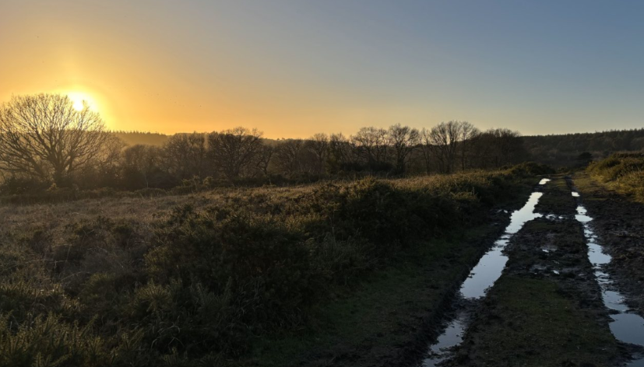
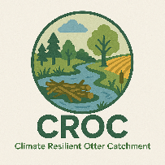
Date of Document: 9th December 2025
Prepared by: Milly Bowden
Authorised by:

Contents
1. Project Officer 2
2. Introduction & Overview 2
3. Scope of the Service 3
A) Site Location 3
B) Site Information 5
C) Services Required 6
D) Timescale 6
E) Special site considerations 7
4. ITT Responses 7
A) Respondent Guidelines 7
B) Tender Assessments: Evaluation and Process 8
C) Confidentiality 8
D) Finance 8
E) ITT Acceptance 8
5. Photographs for Reference 10
Appendix A: Concept Plan 13

Project Officer
For all enquiries and submissions concerning this Invitation to Tender, please contact:

Milly Bowden
Senior Farm Advisor
Westcountry Rivers Trust, Rain-Charm House, Kyl Cober Parc, Stoke Climsland, Callington, Cornwall, PL17 8PH

E: millybowden@wrt.org.uk M: 07930 371207

All enquiries for further information will be answered to all parties.

Introduction & Overview

Client: Westcountry Rivers Trust
Principal Designer: Westcountry Rivers Trust
Principal Contractor: TBC

- Company Background
Westcountry Rivers Trust (WRT) is an environmental charity (Charity №. 1135007, Company №. 06545646) established in 1994 to secure the preservation, protection, development and improvement of the rivers, streams, watercourses, and water impoundments in the West Country, and to advance the education of the public in the management of water and associated habitats.
- Project Background
The 237km2 River Otter catchment rises in the Blackdown Hills and meets the sea at Budleigh Salterton. 103 residential properties flooded in the catchment in May 2023 due to intense rainfall creating significant runoff from agricultural land and protected sites, further runoff has been noted during Storm Ciaran.
The Section 19 Report following the May 2023 flooding makes specific recommendations around the need to deliver NFM upstream of impacted communities, and to better understand and improve land management practices. The ‘Climate Resilient Otter Catchment’ CROC project focuses advice and funding on both land management and NFM.

Scope of the Service

Site Location
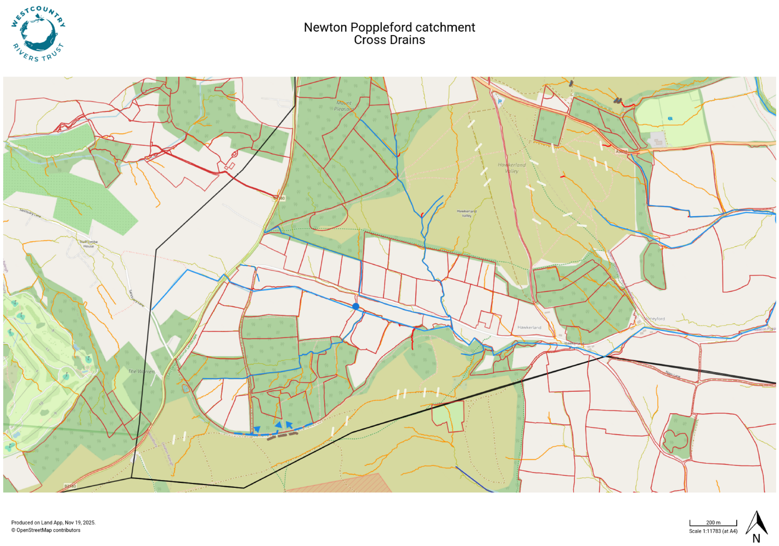
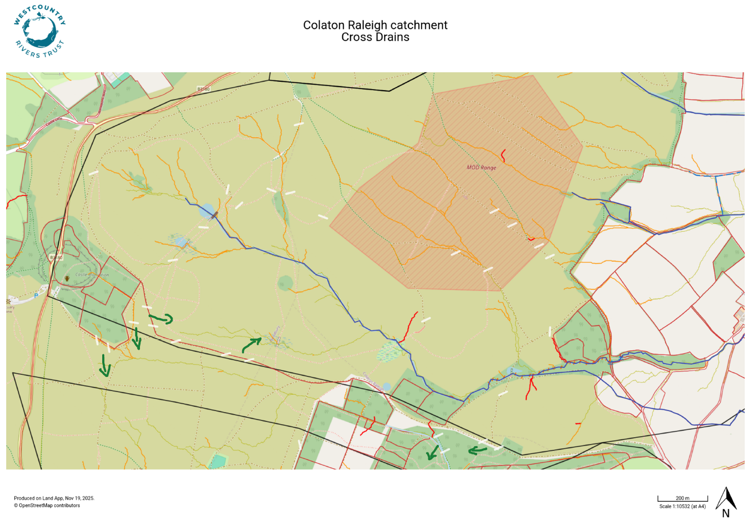

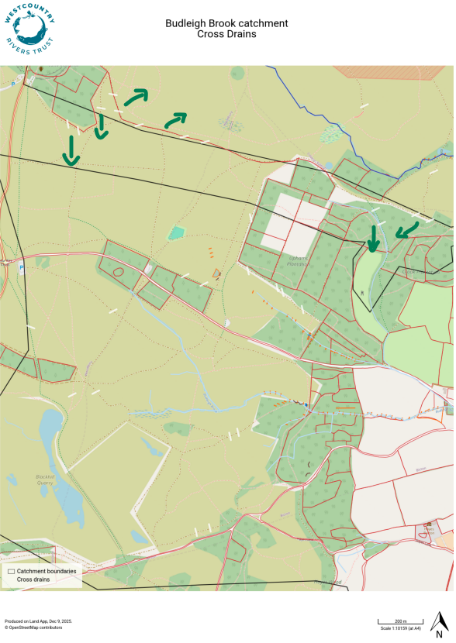

Google maps public car park locations for Pebblebed Heaths access:
Hawkerland: https://maps.app.goo.gl/tYyVA2b41ZrHRcmQ9

Colaton Raleigh Common: https://maps.app.goo.gl/cTSzSMT13G4Q5P8F8
https://maps.app.goo.gl/6WnGmAFXcFAZbMPQA
https://maps.app.goo.gl/fkzLo7DLHAjr6rCM7

Bicton Common: https://maps.app.goo.gl/NquCPW4d5w1uLGCE6

You are welcome to visit the site by arrangement. Please let the Project Officer know if you intend to visit the site to prepare your tender response. A member of WRT staff will organise permission and may accompany you to the site.

Site Information
- Tracks vary in width dependent on location.
- The tracks are used by rangers, forestry, MOD and the general public.
- Tracks are, in most cases, accompanied each side by a flailed width of grass, heather or gorse before thicker gorse or heather. This is a managed fire break system which can have a grip cut through and incorporated into works.
- A small scape (no more than 2m), for water to run in to and settle/infiltrate, can be cut into the gorse/heather but cut material should not be mounded at one end as water should be able to flow into heath land. Do not scrape large areas of heather as this is heathland habitat.
- Track work and maintenance is part of the Pebblebed Heaths SSSI and National Landscape work. Due to the protected status of the landscape and habitats, no additional work than discussed here should be undertaken without prior permission.
- There are no known water supplies (underground) and electricity (overhead) but site checks should be undertaken at each location.

Services Required
- 23 x Newton Poppleford, 24 x Colaton Raleigh, 22 x East Budleigh cross drains
- Grading and sloping of 10-15m of track in various locations
- Creation of a 2-3m wide (downslope) sleeping policeman diagonally (with gradient) across track
- Creation of a grip through the firebreak (2m width)
- Creation of a small, scraped area for track water to pool and infiltrate
- An option of Ground Investigations according to the Consultant’s assessment and agreement with the Client as to whether they are needed.
- Appropriate risk assessments will be required for all elements of the services. Under CDM 2015 this includes a Designers Risk Assessment (DRA).
- Optioneering for the above outcomes is welcomed against your experience. WRT have provided a Concept Plan (Appendix A), based on technical input, however, WRT are not technical design experts, and while operating as Principal Designer under CDM regulations WRT expect the appointed designer to provide comment on feasibility, health and safety, and budget practicality of options based on your technical experience.
- The consultant must ensure that all elements conform to all relevant British and European Standards.
- A draft NEC4 Contract representative of the final version has been supplied. A final version will be provided at appointment, with opportunity to review before acceptance.

Timescale
The tender process is anticipated to follow the timeline presented in the table below:
Date |  |  |  | Action
 |  | 22nd December 2025 | Invitation To Tender released.
 |  | 12th January 2026 | All queries to be submitted.
 |  | 16th January 2026 | All queries to be addressed and returned to all applicants.
 |  | 23rd January 2026 | ITT Deadline for design quotes.
 |  | 30th January 2026 | Notification of intent to award tender
 |  | 14th January 2026 | Signed NEC4 contract awarded & delivered.
 |  | 28th Feb 2026 | Completion of NFM Works although could be later if Pebblebed Heaths Conservation Trust confirm revised date

Special site considerations
Track work and maintenance is part of the Pebblebed Heaths SSSI and National Landscape work. Due to the protected status of the landscape and certain habitats, no additional work, other than discussed here, should be undertaken without prior permission.
Track works and locations have been discussed and approved with Pebblebed Heaths Manager Kim Strawbridge.
No ground work should go further than 2m into uncut heather/gorse vegetation as this is Heath habitat.

ITT Responses

Respondent Guidelines
You are required to submit a written proposal, either hard copy or electronically to the Project Officer by the deadline.
- All proposals should include the following:

- Details of company experience in Natural Flood Management delivery
- Costings: including breakdown of delivery items to allow for partial project invoices, against specified item costs, if required
- An estimation of timescale and outline programme
- Details of staff to be delivering the work including relevant experience (e.g. CV)
- Completed draft NEC4 Contract supplied
- Current insurance certificates for Employer Liability, Professional Indemnity and Public Liability.
- Health & Safety information

- The draft NEC4 template provided requires you to fill out: The Consultant’s insurance details, the Consultant’s Contract Data, the Consultant’s Offer, the Price List, and to sign the contract as a formal offer.
- A detailed breakdown in the Price List of the NEC4 Contract allows for partial project invoices, against the specified item costs, if required.
- You are expected to supply all required information, or clearly state the reason for being unable to do so. Any return supplied must make it clear if any part of the Contractor’s offer does not comply with the Contract Data or the Works Information provided.
- In submitting a quotation, you are stating you are suitably qualified and experienced in work of this nature. If your tender is successful and the contract awarded, you are required to provide:

- Risk Assessments for any site visits planned and work undertaken.
- Details of proposed sub-contractors and current insurances (if applicable)

- Any assumptions used in preparing responses should be clearly stated. Any appropriate supporting documents e.g. programmes, plans, company brochures, organisation charts should be included with the tender submission.

Tender Assessments: Evaluation and Process
- A set of evaluation criteria has been prepared by WRT for the evaluation of every submission. Within each stage an initial evaluation will consider whether or not every requirement contained within the ITT has been fulfilled. The evaluation criteria will be based on price (40%) and quality (60%) with quality being assessed on ability to meet the requirements (25%), delivery/timescales (25%) and staffing arrangement (10%).
- All operations must strictly comply with all relevant Health and Safety, legal requirements and British & European codes of Best Practice.
- If you have any queries, please do not hesitate to contact WRT.

Confidentiality
- All information supplied by WRT in this tender to date, and any further information supplied during the tender process, is confidential and must not be shared with any other organisations unless WRT agree permission in writing. The confidentiality extends to all recipients of this information.
- This competitive invitation to tender process has been performed anonymously. Prospective contractor / invitee details will not be shared with other contractors by WRT. Any sensitive information shared with WRT as part of your response shall remain so between WRT and the prospective contractor. All enquiries for further information will be summarised anonymously and answered to all parties.

Finance
- This project is financed under the Climate Resilient Otter Catchment - CROC.
- Funding for this contract is sponsored by the Environment Agency.
- Invoicing terms are detailed in the NEC4 contract.
- When invoicing, the invoice must clearly state the awarded NEC4 contract.

ITT Acceptance
- To simplify exchange of information regarding this Invitation to Tender (ITT) please nominate one point of contact with relevant telephone number/s and email address.
- Please direct any questions regarding this ITT content or process to the Westcountry Rivers Trust Project Officer. All questions should be submitted to the Project Officer named above.
- Please make sure any questions are submitted in good time for answers to be collated and distributed. A deadline may be in place for any queries to facilitate the fair tendering process for all respondents but should be no later than 1 week prior to submission deadline.
- Where there is a valid reason, WRT reserve the right not to accept your submission, or any other quotations received. WRT are not liable for any cost you may incur in the preparation of your quotation.
- If you have any queries, please do not hesitate to contact WRT and we look forward to receiving your response.

Photographs for Reference
Hawkerland Common
///alerting.orbited.skips | 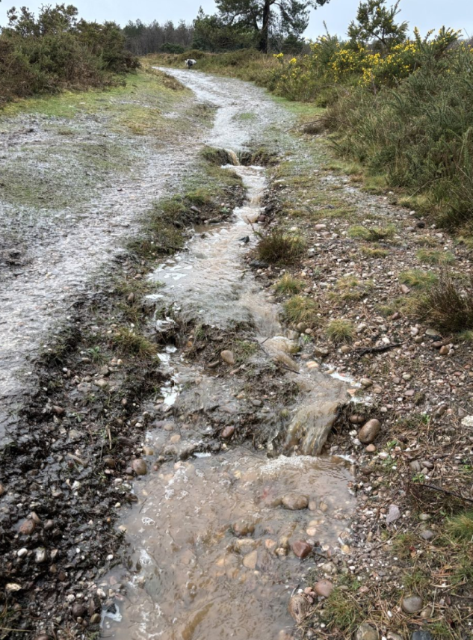
///third.timer.escalates | 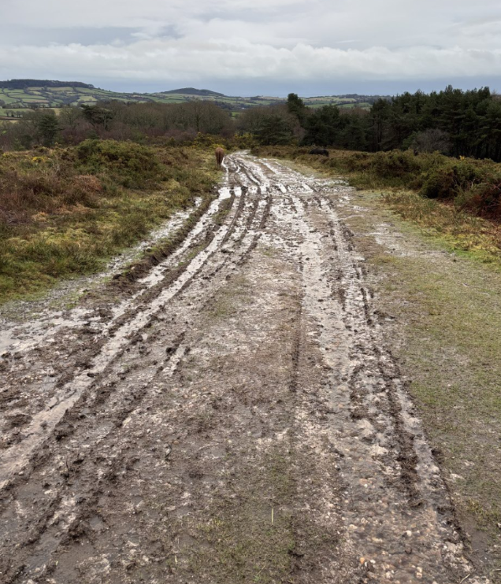
///ruffle.self.repeating | 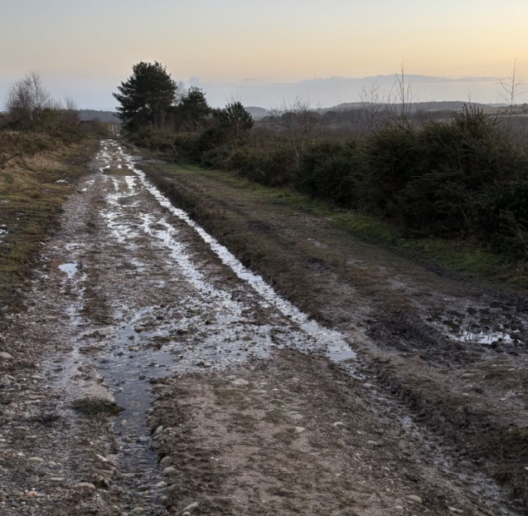

Colaton Raleigh Common
///exploring.zaps.monks | 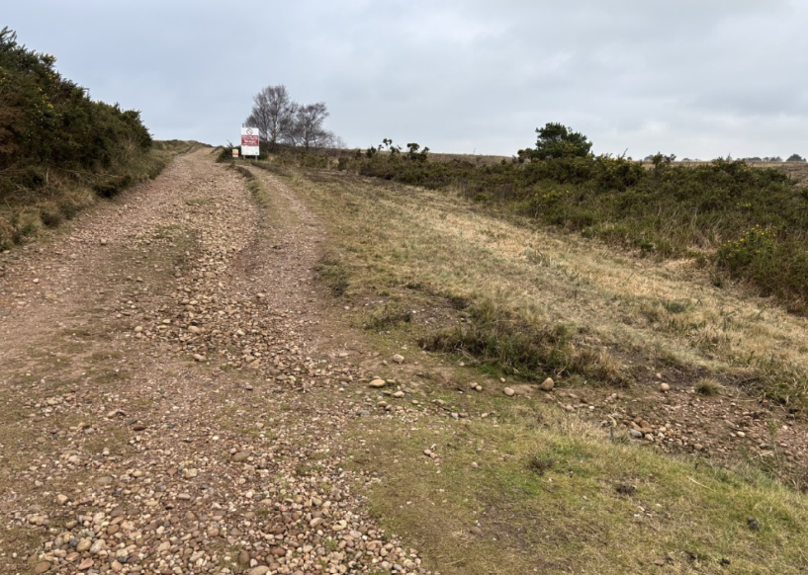
///haggis.eagle.applauded | 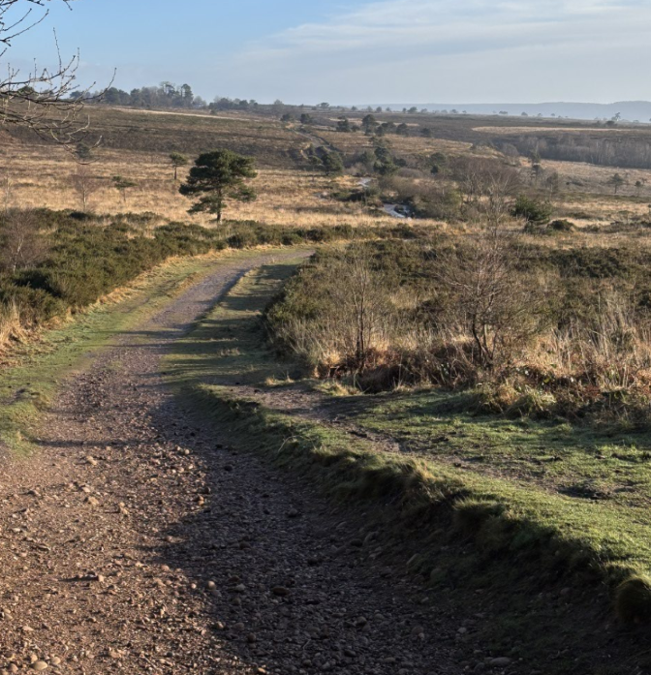
///oldest.uttering.immunity | 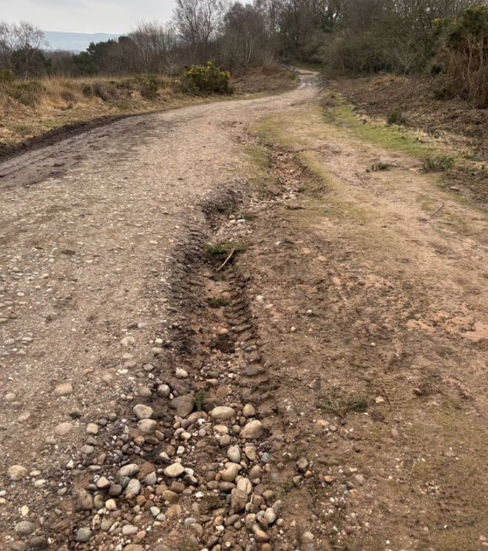

Bicton Common
///showrooms.flatten.grips | 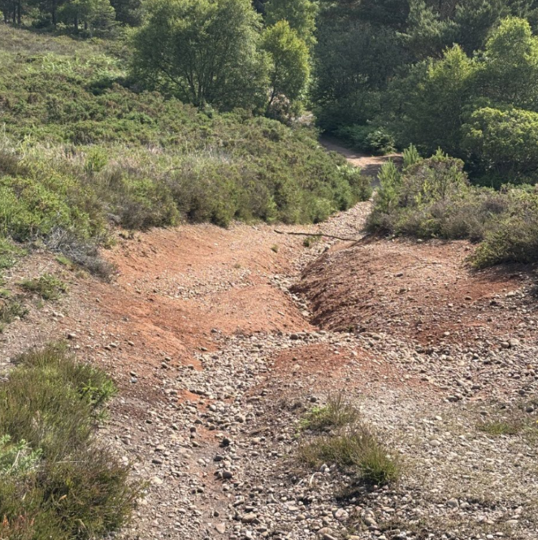
///thread.apprehend.debate | 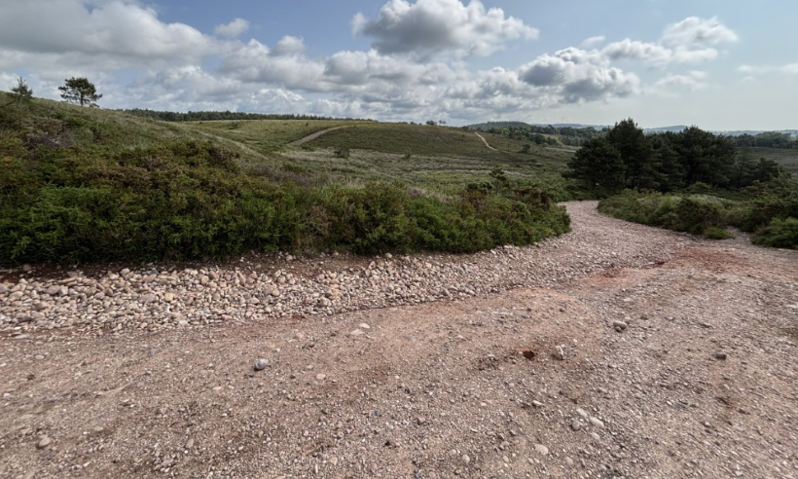
///hovered.pythons.constrain | 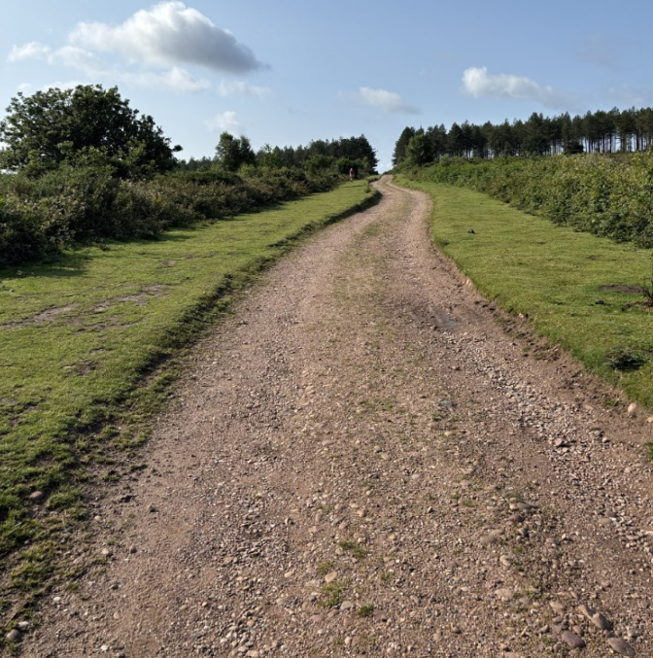

Concept Plan
- Tracks vary in width dependent on location.
- The sleeping policeman should be created from 10-15m of very gently sloping material. The ‘hump’ should be a 2-3m wide and diagonally angled with the slope of the track to divert water. A gentle gradient should be made for the hump as rangers, forestry, MOD and the general public use the tracks. Humps should not be thin and angular as we do not wish to encourage mountain bike jumps.
- Tracks are, in most cases, accompanied each side by a flailed width of grass, heather or gorse before thicker gorse or heather. This is a managed fire break system which should have a 2-3m wide grip cut through, upslope of the hump, and incorporated into works.
- A small scape (no more than 2m), for water to run in to and settle/infiltrate, can be cut into the gorse/heather but cut material should not be mounded at one end as water should be able to flow into heath land. Do not scrape large areas of heather as this is heathland habitat.
