Contract Data:
Engineering and Construction Short Contract

Engineering and Construction

Short Contract

A contract between | Westcountry Rivers Trust  Rain Charm House, Kyl Kober Parc, Stoke Climsland, Cornwall, PL17 8PH

and

for | Natural Flood Management interventions to divert track run off with sleeping policemen cross drains and scrapes on Clinton Devon Estate’s Pebblebed Heaths

Contract Forms

Contract Data

The Contractor’s Offer and Client’s Acceptance

Price List

Scope

Site Information

Notes about the contract are printed in boxes like this
one. They are not part of the contract.

Contract Data

The Client’s Contract Data

The Client is

Name | Westcountry Rivers Trust
Address for communications | Rain Charm House, Kyl Cober Parc, Stoke Climsland, Cornwall, PL17 8PH

Address for electronic communications | millybowden@wrt.org.uk

The works are | Natural Flood Management interventions to divert track run off with sleeping policemen cross drains and scrapes on Clinton Devon Estate’s Pebblebed Heaths

The site is | Pebblebed Heaths, Clinton Devon Estates

The starting date is | 1st February 2025

The completion date is | 15th March 2025

The delay damages are | £50 | per day

The period for reply is | One | weeks

The defects date is | Four | weeks after Completion

The defect correction period is | Eight | weeks

The assessment day is the | Last Thursday | of each month

The retention is | 5 | %

The United Kingdom Housing Grants, Construction and Regeneration Act (1996) does/does not apply
(delete as applicable)

The Adjudicator is

Name | Construction Industry Council (CIC)

Address for communications | Construction Industry Council (CIC)  The Building Centre  26 Store Street  London WC1E 7BT

Address for electronic communications | enquiries@cic.org.uk

Contract Data

The Client’s Contract Data

The interest rate on late payment is | 0.15 | % per complete week of delay.

Insert a rate only if a rate less than 0.5% per week of delay has been agreed.

For any one event, the liability
of the Contractor to the Client
for loss of or damage to the
Client’s property is limited to | 5,000,000

The Client provides this insurance | None

Only enter details here if the Client is to provide insurance.

The minimum amount of
cover for the third insurance
stated in the Insurance Table is,
for any one event | 5,000,000

The minimum amount of
cover for the fourth insurance
stated in the Insurance Table
is, for any one event | 5,000,000

The Adjudicator nominating
body is | Construction Industry Council (CIC)

The tribunal is | Arbitration

If the tribunal is arbitration, the
arbitration procedure is | The latest version of the Institution of Civil Engineers Arbitration Procedure in force when arbitrator is appointed

The conditions of contract are the NEC4 Engineering and Construction Short Contract June 2017 (with amendments October 2020) and the following additional conditions

Only enter details here if additional conditions are required.

None

Contract Data

The Contractor’s Contract Data

The Contractor is

Name | To be completed by the contractor
Address for communications

Address for electronic communications

The fee percentage is |  | %

The people rates are

category of person | unit | rate

The published list of Equipment is

The percentage for adjustment for Equipment is |  | % (state plus
 |  | or minus)

The Contractor’s Offer and Client’s Acceptance

The Contractor offers to Provide the Works in accordance with these conditions of contract for an amount to be determined in accordance with these conditions of contract.

The offered total of the Prices is

Enter the total of the Prices from the Price List.

Signed on behalf of the Contractor

Name

Position

Signature

Date

The Client accepts the Contractor’s Offer to Provide the Works

Signed on behalf of the Client

Name

Position

Signature

Date

Price List

Entries in the first four columns in this Price List are made either by the Client or the tenderer.

If the Contractor is to be paid an amount for the item which is not adjusted if the quantity of work in the item changes, the tenderer enters the amount in the Price column only; the Unit, Quantity and Rate columns being left blank.

If the Contractor is to be paid an amount for the item of work which is the rate for the work multiplied by the quantity completed, the tenderer enters the rate which is then multiplied by the expected quantity to produce the Price, which is also entered.

ITEM NUMBER | DESCRIPTION | UNIT | QUANTITY | RATE | PRICE

The total of the Prices | TBC

The method and rules used to compile the Price List are

Scope

The Scope should be a complete and precise statement of the Client’s requirements. If it is incomplete or imprecise there is a risk that the Contractor will interpret it differently from the Client’s intention.

Information provided by the Contractor should be listed in the Scope only if the Client is satisfied that it is required, is part of a complete statement of the Client’s requirements and is consistent with the other parts of the Scope.

1 Description of the works

Give a detailed description of what the Contractor is required to do and of any work the
Contractor is to design.

Services Required:
- Cross Drains at the following locations: 3 x Newton Poppleford, 24 x Colaton Raleigh, 22 x East Budleigh
- Grading and sloping of 10-15m of track in various locations (see maps)
- Creation of a 2-3m wide (downslope) sleeping policeman diagonally (with gradient) across track
- Creation of a grip through the firebreak (2m width)
- Creation of a small, scraped area for track water to pool and infiltrate
- An option of Ground Investigations according to the Consultant’s assessment and agreement with the Client as to whether they are needed.
- Appropriate risk assessments will be required for all elements of the services. Under CDM 2015 this includes a Designers Risk Assessment (DRA).
- Optioneering for the above outcomes is welcomed against your experience. WRT have provided a Concept Plan (Appendix A), based on technical input, however, WRT are not technical design experts, and while operating as Principal Designer under CDM regulations WRT expect the appointed designer to provide comment on feasibility, health and safety, and budget practicality of options based on your technical experience.
- The consultant must ensure that all elements conform to all relevant British and European Standards.
Concept Plan:
- The sleeping policeman should be created from 10-15m of very gently sloping material. The ‘hump’ should be a 2-3m wide and diagonally angled with the slope of the track to divert water. A gentle gradient should be made for the hump as rangers, forestry, MOD and the general public use the tracks. Humps should not be thin and angular as we do not wish to encourage mountain bike jumps.
- Tracks are, in most cases, accompanied each side by a flailed width of grass, heather or gorse before thicker gorse or heather. This is a managed fire break system which should have a 2-3m wide grip cut through, upslope of the hump, and incorporated into works.
- Please note that tracks vary in width dependent on location.
- A small scape (no more than 2m), for water to run in to and settle/infiltrate, can be cut into the gorse/heather but cut material should not be mounded at one end as water should be able to flow into heath land. Do not scrape large areas of heather as this is heathland habitat.
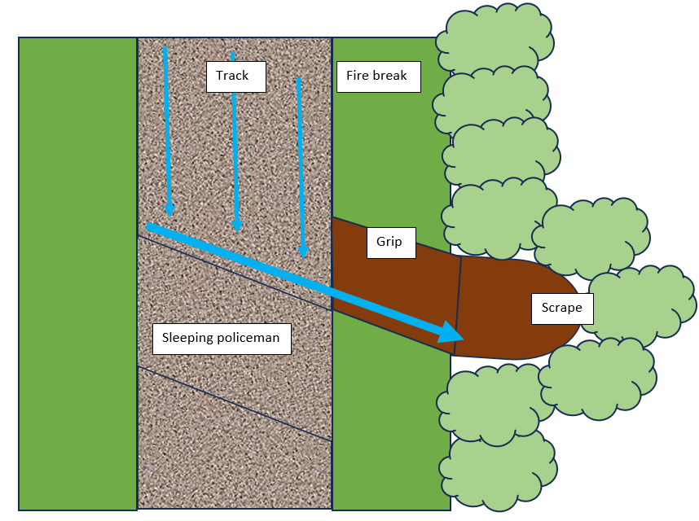
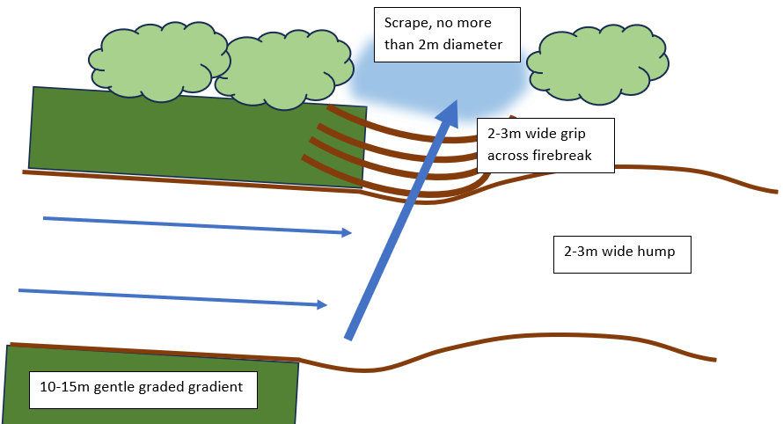

For further information, please refer to the Invitation to Tender.

2 Drawings

List the drawings that apply to the contract.

DRAWING NUMBER | REVISION | TITLE

Scope

3 Specifications

List the specifications which apply to the contract.

TITLE | DATE OR REVISION | TICK IF PUBLICLY AVAILABLE
Invitation to Tender | 1

4 Constraints on how the Contractor Provides the Works

State any constraints on the sequence and timing of work and on the methods and conduct of work including the requirements for any work by the Client.

Communications
- While the Client is Westcountry Rivers Trust, the site is in the Clinton Devon Estates ownership and management. Communications will need to involve the Westcountry Rivers Trust project manager as well as Pebblebed Heaths Manager Kim Strawbridge. Site access specifically will need to be coordinated with Clinton Devon Estates, the landowner.

Health and Safety
- The Pebblebed Heaths is open access land with Military of Defence, forestry and conservation operations also occurring. All gates should be opened and closed immediately behind to limit vehicular access.
- Access should be discussed with Kim Strawbridge of the Pebblebed Heaths Conservation Trust and Clinton Devon Estates
- Ground conditions may change and disturbance should be kept to a minimum-do NOT stray into heathland. The tracks are in a protected habitat and designated SSSI.

Works must be completed by the 1st March as best you can to avoid bird nesting season.

Where the Consultant intends to subcontract part of the works, this should be agreed with the Client in advance. The Consultant should ensure that Health & Safety due diligence is carried out and provided to the Client in respect of the Subcontractor either in the form of the WRT Health & Safety Assessment Form or equivalent. As per Condition 21 of the Contract, if the Consultant subcontracts work, it is responsible for Providing the Service as if it had not been subcontracted. Where a Subcontractor is used, The Client reserves the right to instruct the Consultant to stop using a person to Provide the Service.

Any disputes are to be resolved in the first instance by the Project Managers of the Client and Consultant. Where a resolution between these two designated individuals is not possible, the dispute should be escalated to the Chief Executives of the parties for resolution. Should the Chief Executives fail to reach agreement the dispute is to be referred to a neutral third party for mediation / conciliation. Only when these steps fail should the dispute be resolved in line with the Contract Data as set out on page 4 of this contract

Scope

5 Requirements for the programme

State whether a programme is required and, if it is, state what form it is to be in, what information is to be shown on it, when it is to be submitted and when it is to be updated.

State what the use of the works is intended to be at their Completion as defined in clause
11.2(1).

Works must be completed by the 1st March 2026 to avoid bird nesting season.

Monthly meetings to be held between the client and the contractor.

6 Services and other things provided by the Client

Describe what the Client will provide, such as services (including water and electricity) and ‘‘free issue’’ Plant and Materials and equipment.

ITEM | DATE BY WHICH IT WILL BE PROVIDED

Site Information

Give information about the site such as the ground conditions and any other information which is likely to affect the Contractor’s work such as the position of adjacent structures.

The multiple site areas are located on the Pebblebed Heaths, Clinton Devon Estate.
- The land is in the East Devon AONB and is in the Pebblebed Heaths SSSI. SSSI consent is not required as work is restricted to tracks which falls under the Pebblebed Heaths Conservation Trust maintenance plan.
- The landowner is Clinton Devon Estates.
- This site has designated status and any concerns or queries should be directed to Milly Bowden and the Pebblebed Heaths manager Kim Strawbridge.
- The tracks are used by rangers, forestry, MOD and the general public.

Newton Poppleford access: ///packages.hips.flickers

Colaton Raleigh access: ///avid.hurls.defected
///quits.buildings.resemble
East Budleigh access: ///lashed.headrest.distracts

Google maps public car park locations for Pebblebed Heaths access:
Hawkerland: https://maps.app.goo.gl/tYyVA2b41ZrHRcmQ9
Colaton Raleigh Common: https://maps.app.goo.gl/cTSzSMT13G4Q5P8F8
https://maps.app.goo.gl/6WnGmAFXcFAZbMPQA
https://maps.app.goo.gl/fkzLo7DLHAjr6rCM7
Bicton Common: https://maps.app.goo.gl/NquCPW4d5w1uLGCE6

